**find Assignment**

Mandatory:

1. **Search and display all *.c and *.h files in all subdirectories starting from current directory**

find . -type f \( -name "*.c" -o -name "*.h" \)

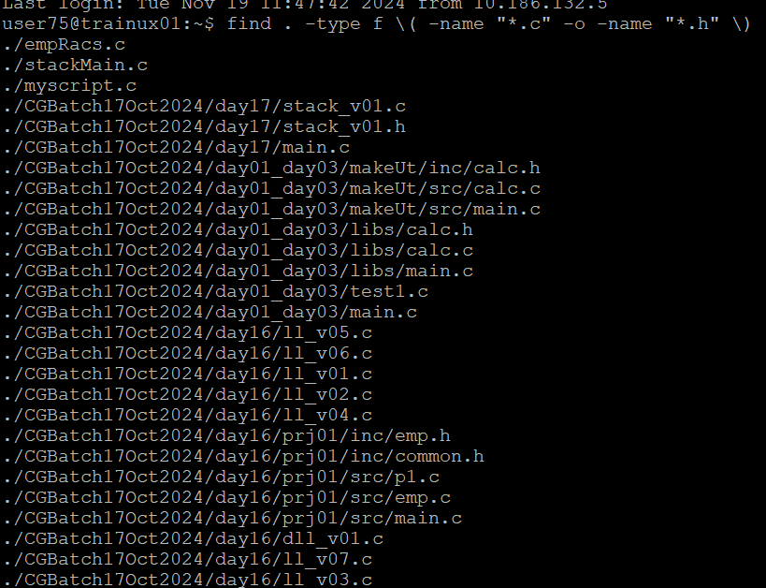

1. **Search and display all directories in all subdirectories starting from current directory**

find . -type d

1. **Search and display all files with permissions only rw with user and execute permission for others**

find -type f -perm /u+rw

